**Section 3: Extended answer 40% (80 Marks)**

This section contains **six (6)** questions. You must answer **all** questions. Write your answers in the spaces provided.

Spare pages are included at the end of the booklet. They can be used for planning your responses and/ or as additional space if required to continue an answer.

* Planning: If you use the spare pages for planning, indicate this clearly at the top of the page.
* Continuing an answer: If you need the space to continue an answer, indicate in the original answer space where the answer is continued, i.e. give the page number. Fill in the number of the question(s) that you are continuing to answer at the top of the page.

Suggested working time for this section is 70 minutes.

______________________________________________________________________________

**Question 37 (14 marks)**

**Aspirin**, also known as **acetylsalicylic acid** is a drug that is often used as an analgesic to relieve minor aches and pains, as an antipyretic to reduce fever, and as an anti-inflammatory medication.

A sample of aspirin was prepared by reacting 2.20 g of salicylic acid with 4.20 mL of ethanoic anhydride in a conical flask. After heating for 20 minutes the reaction mixture was cooled and white crystals precipitated. The crystals were then collected, dried to constant mass and weighed.

The equation for the reaction is:

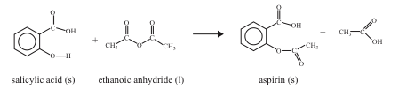

The following results were obtained

Mass of salicylic acid 2.20 g

Volume of ethanoic anhydride 4.20 mL

Mass of product 2.25 g

(a) Complete the following table (molar mass only) and use the data to answer the questions below.

|  |  |  |
| --- | --- | --- |
|  | Molar mass (gmole-1) | Density (gmL-1) |
| Aspirin | ***180.154*** | Not given |
| Ethanoic anhydride | ***102.092*** | 1.08 |
| Salicylic acid | ***138.118*** | Not given |

(3 marks)

(b) Calculate the initial amount, in moles, of salicylic acid used in this preparation.

***N = m/M = 2.20/138.118 = 0.01593 mole***

(1 mark)

(b) What initial amount, in moles, of ethanoic anhydride was used?

***D = m/V , m = 1.08 x 4.2 = 4.536g***

***n = 4.536/102.092 = 0.04443 mole***

(2 marks)

(c) What is the maximum mass of aspirin that can theoretically be produced from these reagents?

***1 mole of salicylic acid (SA) reacts with 1 mole of athanoic anhydride (EA)***

***n(SA) < n(EA)***

***SA is the limiting reagent***

***n(aspirin) = n(SA) = 0.02073 mole***

***m(aspirin) = 0.01593 x 164.163 = 2.87g***

(3 marks)

(d) Determine the percentage of salicylic acid converted to aspirin (percentage yield) in this preparation.

***% conversion = m(aspirin)/theoretical mass x 100***

***= 2.25/2.87 x 100 = 78.4%***

(2 marks)

(e) The sodium salt of aspirin is more soluble than aspirin itself. This salt may be synthesised by reaction between aspirin and sodium hydrogen carbonate as follows.

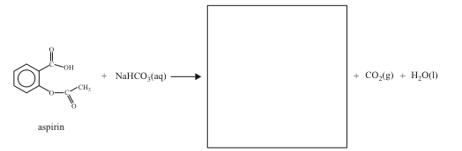

(i) In the box provided above, give the complete structure for the **sodium salt of aspirin**

(1 mark)

(ii) Explain why the sodium salt of aspirin is more water-soluble than aspirin.

***Aspirin is covalent molecular. The –OH on the carboxylic acid group will form hydrogen bonds with water. This makes the aspirin partially soluble in water. The sodium salt ionises forming stronger ion – dipole interactions with the water molecules in water making it more soluble.***

(2 marks)

**Question 38 (14 marks)**

A compound was analysed to determine its empirical formula. The compound contained nickel, chlorine, carbonate and water and had the general formula NiwClx(CO3)y .zH2O.

1.684 g of the compound was heated to drive off the water. The mass of compound was

determined a number of times during the heating and the following data was obtained:

|  |  |
| --- | --- |
| Time (hours) | Mass (g) |
| 0 | 1.684 |
| 1 | 1.401 |
| 2 | 1.386 |
| 3 | 1.383 |
| 4 | 1.383 |

1. Why was the compound heated and measurements of mass taken over a period of 4 hours?

***It must be heated to constant mass to ensure all of the water of crystallization is removed from the hydrated compound***

(2 marks)

One third of the anhydrous dry compound was dissolved and H2S gas was bubbled through the

solution. 0.338 g of NiS was precipitated.

Another one third of the anhydrous compound was treated with silver nitrate producing

0.532 g of silver chloride.

The remaining third of the anhydrous compound was analysed by combustion and 0.082 g

of carbon dioxide was produced.

(b) Determine the values of w, x, y and z in the general formula above.

***m(water) = 1.684 - 1.383 = 0.301g***

***n(water) 0301/18 = 0.01672mole***

***compound is divide into 3***

***n(NiS) = 0.338/90.79 = 0.00372 mole***

***n(Ni) = 0.00372 mole***

***n(Ni) in the original sample = 0.00372 x 3 = 0.01116 mole***

***n(AgCl) = 0.532/143.4 = 0.00371 mole***

***n(Cl) = 0.00371 mole***

***n(Cl) in the original sample = 0.00371 x 3 = 0.01113 mole***

***n(CO2) = 0.082/44 = 0.001864 mole***

***n(CO3) = 0.001864***

***n(CO3) in the original sample = 0.001864 x 3 = 0.005592 mole***

***n(Ni) : Cl : CO3 : H2O***

***= 0.01116 : 0.01113 : 0.005592 : 0.01672***

***= 2 : 2 : 1 : 3***

***EF = Ni2Cl2(CO3).3H2O***

(12 marks)

______________________________________________________________________________

**Question 39 (20 Marks)**

Ethanol is not the only alcohol gaining in popularity as a fuel. Methanol, CH3OH, is also the subject of considerable research; especially for use in fuel cells. The commercial production of methanol, however, is quite different to that of ethanol and involves a two step process.

**Step 1 Production of hydrogen gas**

Large quantities of hydrogen, for industrial use, are produced through steam methane reforming (SMR). Steam reforming converts methane (and other hydrocarbons in natural gas) into hydrogen and carbon monoxide by reaction with steam over a nickel catalyst.

**CH4(g) + H2O(g) ⬄ CO(g) + 3H2(g); Δ*H* = +206 kJ mol -1**

Temperatures of about 850°C and pressures of 1000 kPa to 2000 kPa are used in this step.

Some methane and steam are placed in a closed container and allowed to react at a fixed temperature. The following graph shows the change in concentration of methane and carbon monoxide as the reaction progresses.

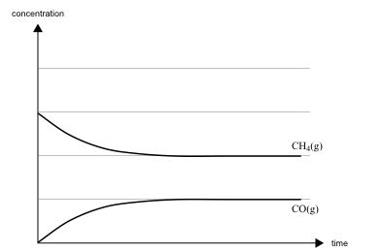

(a) (i) On the graph above, draw a line to show the change in concentration of hydrogen gas as the reaction progresses. **Label this line H2**. (2 marks)

(ii)On the graph above, draw a line to show how the formation of carbon monoxide would differ over time in the presence of a catalyst. **Label this line**. (2 marks)

**Step 2 Production of Methanol**

Hydrogen and carbon monoxide are reacted to form methanol using a mixture of ZnO and CrO3 as a catalyst.

**CO(g) + 2H2(g)** ⬄ **CH3OH(g) Δ*H* = -92 kJ mol-1**

Temperatures of about 300oC and pressures of 5000 kPa to 10 000 kPa are used in this step.

(b) In terms of equilibrium **and** rate, explain why

(i)elevated temperatures are used in both steps with the temperature used in step 1 being much higher than in step 2.

***Elevated temperature favours rate in both. High T favours equilibrium yield in Step 1 (endothermic) but not in Step 2 (exothermic)***

(3 marks)

(ii)pressures higher than atmospheric are used in both steps, with the pressure used in step 2 being much higher than in step 1.

***High pressure favours rate in both. High P favours the reactant in Step 1 but favours products in Step 2***

(3 marks**)**

(iii)a catalyst is used in both steps.

***Increase the rate and reduce the need for high T and P***

(1 mark)

(c) Identify one way in which the energy efficiency of this method of methanol production can be maximised.

***Use the heat produced in Step 2 (exothermic) to drive Step 1 (endothermic)***

(1 mark)

(d)The following changes are made to a gaseous equilibrium mixture of CO, H2 and CH3OH at 300oC. Indicate in the table below the effects on the masses of CO, CH3OH and H2 present at the new equilibrium by entering the words 'increase' or 'decrease' or ‘no change’ as appropriate.

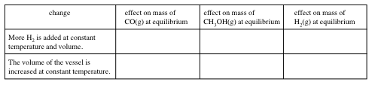

(6 marks)

(e)The following graph represents the change in the number of mole of carbon monoxide with time during an experiment in which the volume of the vessel is changed at constant temperature.

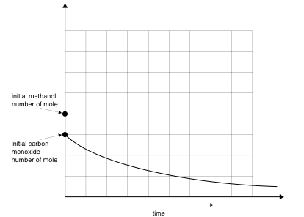

On this graph sketch and label a line showing how the number of mole of methanol would have changed over the same period of time.

(1 mark)

In a newer version of the Steam Methane Reforming (SMR) process described in

Step 1,

CH4(g) + H2O(g) ⬄ CO(g) + 3H2(g)

the reforming reactions occur in a tube surrounding a palladium membrane. The membrane selectively separates hydrogen from the gas mixture.

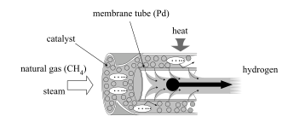

(f)Explain why the separation of hydrogen in this way increases the yield of hydrogen obtained.

***By removing hydrogen through the membrane tube the concentration of product in the equilibrium is being reduced. This drives the reaction to the product side (LCP) increasing the amount and yield of the hydrogen being produced***

(3 marks)

**Question 40 (10 Marks)**

Alpha amino acids are the monomers that living organisms use to produce proteins

(a) The general structure of an alpha amino acid is shown in the box below.

|  |  |  |
| --- | --- | --- |
| mino Acid  Valine | mino Acid  Cysteine | mino Acid  Phenylalanine |

(i) What does the term “alpha” mean?

***The amine group is on the no. 2 carbon atom or adjacent to the COOH. OR the amine and carboxylic acid functional groups are attached to the same terminal C atom. (text)***

(1 mark)

(ii) Draw a structure in the box below showing how peptide (amide) bonds are formed between these three molecules in the order they appear in the boxes above.

|  |
| --- |
|  |

(2 marks)

(iv) What is the by product of this reaction?

***Water. It is formed when –COOH forms a bond with –NH2 forming CONH2***

(1 mark)

(b) The reaction depicted below is the condensation reaction for the production of nylon.

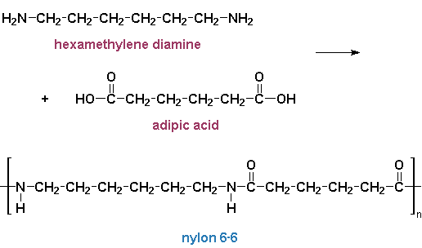

1. What are the similarities between the polypeptide reaction and the nylon production above.

***Polymerisation is a condensation of an amine and a carboxylic acid in both with the formation of water***

(2 marks)

(ii) What are the differences between the reactants in the polypeptide reaction and the nylon production.

***In nylon production a dicarboxylic acid and diamine condense. In formation of a polypeptide amino acids with an acid and an amine group condense***

(2 marks)

**Question 41 (10 marks)**

Myrcene is a naturally occurring compound found in the leaves of bay trees. It is known to be a polyunsaturated hydrocarbon (an unsaturated hydrocarbon with an unknown number of double bonds). It can react with hydrogen to produce a saturated hydrocarbon.

In a laboratory investigation, a 1.00 g sample of pure myrcene **reacted completely** with exactly 510 mL of hydrogen gas measured at 20.0°C and 105.0 kPa. In this reaction, myrcene was converted to a saturated alkane with a molecular formula C10H22.

(a) What type of reaction has occurred between the myrcene and hydrogen?

***Addition reaction***

(1 mark)

(b) Calculate the number of moles and mass, of hydrogen reacting.

***PV = nRT***

***0.51 x 105 = n x 8.31 x 293***

***n = 0.022 mole***

***m(H2) = 0.022 x 2.016 = 0.0443g***

(3 marks)

(c) Calculate the mass of C10H22 produced in the reaction.

***m(C10H22) = m(myrcene) + m(H2)***

***= 0.0443 + 1.00g = 1.0443g***

(2 marks)

(d) Calculate the number of moles of C10H22 and hence the number of moles of myrcene in the original sample.

***n = 1.0443/142.276 = 0.007339 mole***

***n(myrcene) = n(C10H22) = 0.007339 mole***

(2 marks)

(e) Determine the number of double bonds in each molecule of myrcene.

***No. of double bonds = no. of hydrogen molecules added per molecule.***

***= n(H2)/n(myrcene) = 0.022/0.007339 = 3 double bonds***

(2 marks)

**Question 42 (12 marks)**

Select a row (an example is Period 3) of the Periodic Table and describe and explain the relationship between the number of valence electrons and an element’s

1. **bonding capacity** (the number of electrons an atom can gain, lose or share)
2. **ionisation energy**
3. **physical and chemical properties**

Your answer should be approximately one to two pages in length. Use (i) to (iii) above as sub-headings.

***Bonding Capacity***

***The bonding capacity of an element is the number of electrons it can gain, lose or share. Using the 3rd period as an example.***

|  |  |  |  |  |  |  |  |  |
| --- | --- | --- | --- | --- | --- | --- | --- | --- |
| ***Element*** | ***Na*** | ***Mg*** | ***Al*** | ***Si*** | ***P*** | ***S*** | ***Cl*** | ***Ar*** |
| ***Valence electrons*** | ***1*** | ***2*** | ***3*** | ***4*** | ***5*** | ***6*** | ***7*** | ***8*** |
| ***Bonding capacity*** | ***Lose 1 e*** | ***Lose 2 e*** | ***Lose 3 e*** | ***Share 4 e*** | ***Share/ gain 3 e*** | ***Share/ gain 2 e***  ***Share 6 e*** | ***Share/ gain 1 e***  ***Share 7*** | ***No bonding capacity*** |
| ***examples*** | ***Na+*** | ***Mg2+*** | ***Al3+*** | ***SiCl4*** | ***PCl3***  ***P3-*** | ***H2S***  ***S2-***  ***SO42-*** | ***HCl***  ***Cl-***  ***ClO4-*** |  |

***Ionisation energy***

***Ionisation energy is the energy required to remove the most loosely bound electron from an atom. Ionisation energy increases from left to right across the 3rd period.***

***As the number of valence electrons increase across the period, they are all filling the 3s and 3p energy levels. As the number of protons increases across the period, electrostatic attraction from the protons towards the electrons also increases and they become more difficult to remove.. (i.e. require more energy ).***

***Physical and Chemical Properties***

1. ***Physical***

***Physical properties of the elements are related to the bonding within the element.***

***Na, Mg, Al metallic***

***Si covalent network***

***P4, S8, Cl2 Covalent molecular***

***The bonding within a metal is a lattice of positive ions bound by a sea of delocalised electrons. As valence electrons increase from Na to Al, MP increases because each successively donates more electrons to the structure and because the nuclear charge increases, in turn increasing the electrostatic forces of attraction.Free moving valence electrons make the metals thermally and electrically conductive. Non directional bonds give metals the properties of malleability and ductility***

***The valence electrons in Si are localised within a continuous lattice of Si atoms covalently bonded in a tetrahedral arrangement. Covalent bonding is strong. Si is hard and brittle, has a high melting point. As there are no free moving charged particles, Si is non conductive***

***The valence electrons in P, S and Cl are localised within covalent molecules. There are only weak dispersion forces binding the molecules in the solid state. All have low MP and BP and are soft and brittle. All are non conductive.***

***All 8 valence electrons in argon are localised around argon atoms. It has a complete valence energy level and does not form chemical bonds with atoms of any other element or itself. Intermolecular forces within argon are weak dispersion forces. It has a very low MP and BP, and is non conductive as a solid.***

1. ***Chemical Properties***

***The general chemical properties of the elements are related in part to the electron attracting power of an atom (electronegativity.***

***Na has the lowest electronegativity (IE as well) and in a chemical reaction will always lose its valence electron to form a 1+ ion. The other metals in the period behave similarly, but because of the increasing nuclear charge and because 2 and 3 electrons need to be removed from Mg and Al in a chemical reaction, the ease with which they lose their electrons (reactivity) decreases from Group 1 to 2 to 13.***

***Cl has the highest electronegativity of the elements in period 3 and will most readily remove an electron from a metal atom to form a -1 ion. This capacity decreases as S and P need to remove 2 and 3 electrons to form ions and because the electronegativity decreases going from group 17 to 15***